LAB-05 TASKS

IMPORTANT NOTE: Sir my laptop has drivers issue so whole display is distorted and is not straight that’s why my output on vs code has issues, sorry for that. And code is actually fine because I copied that instead of pasting screenshot.
TASK-1 (Code)
class Student {
static int totalStudents = 0;
private int ID;
private String name;

//Setters and Getters
public void setID(int ID) {
this.ID = ID;
}
public int getID() {
return ID;
}
public void setName(String name) {
this.name = name;
}
public String getName() {
return name;
}

//Constructor
public Student(int ID, String name) {
this.ID = ID;
this.name = name;
Student.totalStudents++;
}

//Static Method
public static void displayTotal() {
System.out.println("\nTotal no. of students: " + totalStudents);
}

//Method to display details
public void displayInfo() {
System.out.println("==== Student Details ====");
System.out.println("ID : " + ID);
System.out.println("Name : " + name);
}
}

class task1 {
public static void main(String[] args) {
Student s1 = new Student(123, "Ali");
Student s2 = new Student(456, "Sherry");
Student s3 = new Student(789, "Owais");

s1.displayInfo();
s2.displayInfo();
s3.displayInfo();

Student.displayTotal();
}
}
Output (Task-1):
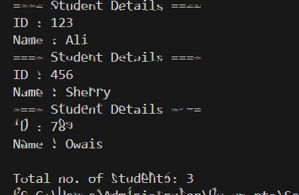
TASK-2 (Code)
WITH COMPOSITION:
class Laptop {
private String brandName;
private int ram; //in GB
private int batteryCapacity; //in mAh

//Setters and Getters
public void setBrandName(String brandName) {
this.brandName = brandName;
}
public String getBrandName() {
return brandName;
}
public void setRam(int ram) {
this.ram = ram;
}
public int getRam() {
return ram;
}
public void setBatteryCapacity(int batteryCapacity) {
this.batteryCapacity = batteryCapacity;
}
public int getBatteryCapacity() {
return batteryCapacity;
}

//Constructor
public Laptop(String brandName, int ram, int batteryCapacity) {
this.brandName = brandName;
this.ram = ram;
this.batteryCapacity = batteryCapacity;
}

//Methods
public double calculateBatteryBackup() {
return batteryCapacity / (ram * 500.0);
}
}

class Student {
private int ID;
private String name;
private Laptop laptop;

//Setters and Getters
public void setID(int ID) {
this.ID = ID;
}
public int getID() {
return ID;
}
public void setName(String name) {
this.name = name;
}
public String getName() {
return name;
}

//Constructor
public Student(int ID, String name, String brandName, int ram, int batteryCapacity) {
this.ID = ID;
this.name = name;
laptop = new Laptop(brandName, ram, batteryCapacity);
}

//Method
public void displayInfo() {
System.out.println("==== Student Information ====");
System.out.println("ID : " + ID);
System.out.println("Name : " + name);
System.out.println("----Laptop Info----");
System.out.println("Brand name : " + laptop.getBrandName());
System.out.println("Ram : " + laptop.getRam());
System.out.println("Battery Capacity : " + laptop.getBatteryCapacity());
System.out.println("Battery Backup : " + laptop.calculateBatteryBackup() + " hours");
}
}

public class task2 {
public static void main(String[] args) {
Student s1 = new Student(456, "Sherry", "Dell", 8, 4500);
Student s2 = new Student(123, "Ali", "Lenovo", 16, 5000);

s1.displayInfo();
s2.displayInfo();
}
}

------------------------------------------------------------------------------------------------------------------------------------------

WITH AGGREGATION:
class Laptop {
private String brandName;
private int ram; //in GB
private int batteryCapacity; //in mAh

//Setters and Getters
public void setBrandName(String brandName) {
this.brandName = brandName;
}
public String getBrandName() {
return brandName;
}
public void setRam(int ram) {
this.ram = ram;
}
public int getRam() {
return ram;
}
public void setBatteryCapacity(int batteryCapacity) {
this.batteryCapacity = batteryCapacity;
}
public int getBatteryCapacity() {
return batteryCapacity;
}

//Constructor
public Laptop(String brandName, int ram, int batteryCapacity) {
this.brandName = brandName;
this.ram = ram;
this.batteryCapacity = batteryCapacity;
}

//Methods
public double calculateBatteryBackup() {
return batteryCapacity / (ram * 500.0);
}
}

class Student {
private int ID;
private String name;
private Laptop laptop;

//Setters and Getters
public void setID(int ID) {
this.ID = ID;
}
public int getID() {
return ID;
}
public void setName(String name) {
this.name = name;
}
public String getName() {
return name;
}

//Constructor
public Student(int ID, String name, Laptop laptop) {
this.ID = ID;
this.name = name;
this.laptop = laptop;
}

//Method
public void displayInfo() {
System.out.println("==== Student Information ====");
System.out.println("ID : " + ID);
System.out.println("Name : " + name);
System.out.println("----Laptop Info----");
System.out.println("Brand name : " + laptop.getBrandName());
System.out.println("Ram : " + laptop.getRam());
System.out.println("Battery Capacity : " + laptop.getBatteryCapacity());
System.out.println("Battery Backup : " + laptop.calculateBatteryBackup() + " hours");
}
}

public class task2 {
public static void main(String[] args) {
Laptop l1 = new Laptop("Dell", 8, 4500);
Laptop l2 = new Laptop("Lenovo", 16, 5000);
//Laptop objects created in main and passed as parameters (aggregation)
//So their lifecycle is independent of Student class
Student s1 = new Student(456, "Sherry", l1);
Student s2 = new Student(123, "Ali", l2);

s1.displayInfo();
s2.displayInfo();
}
}

Output (Task-2):
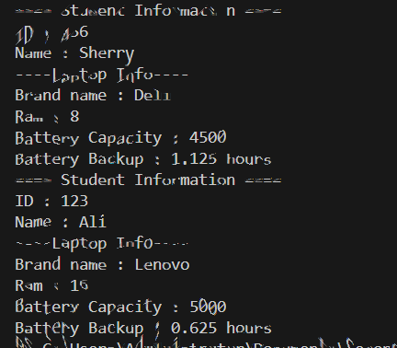
TASK-3 (Code):
Sir sorry the distortion is due to display drivers issue…..

class Employee {
private int ID;
private String name;
private double basicSalary;
//Static fields shared by all object:
private static double bonusPool = 0; //global/total bonus pool
private static double bonusPercentage = 10; //assumed fixed
private static int totalEmployees = 0;

//Constructor
public Employee(int ID, String name, double basicSalary) {
this.ID = ID;
this.name = name;
this.basicSalary = basicSalary;
bonusPool = bonusPool + (basicSalary * bonusPercentage / 100);
totalEmployees++;
}

//Getters
public int getId() {
return ID;
}
public String getName() {
return name;
}
public double getBasicSalary() {
return basicSalary;
}

//Methods
public double calculateTotalCompensation() {
return (basicSalary + (bonusPool / totalEmployees));
}

public static void displayBonusPool() {
System.out.println("Total Bonus Pool: " + Employee.bonusPool);
}

public void displayInfo() {
System.out.println("==== Employee Details ====");
System.out.println("ID: " + ID);
System.out.println("Name: " + name);
System.out.println("Basic salary: " + basicSalary);
System.out.println("Total Compensation: " + calculateTotalCompensation() + "\n");
}
}

public class task3 {
public static void main(String[] args) {
Employee e1 = new Employee(123,"Sherry", 20000);
Employee e2 = new Employee(456, "Ali", 30000);
Employee e3 = new Employee(789, "Owais", 35000);
Employee e4 = new Employee(101, "Shayan", 45000);

e1.displayInfo();
e2.displayInfo();
e3.displayInfo();
e4.displayInfo();

Employee.displayBonusPool();
}
}

Output (Task-3):

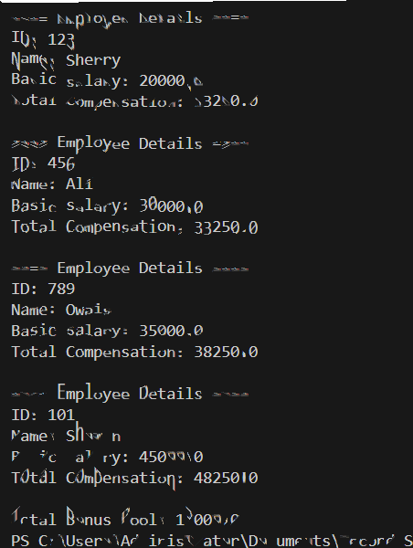

TASK-4 (Code)
class Device {
private int deviceID;
private double powerRating; //in watts
private double hoursUsedPerDay; //per day

//Constructor
public Device(int deviceID, double powerRating, double hoursUsedPerDay){
this.deviceID = deviceID;
this.powerRating = powerRating;
this.hoursUsedPerDay = hoursUsedPerDay;
}

//Method
public double calculateDailyEnergyUsage(){
return (powerRating * hoursUsedPerDay);
}
}

class Room {
private Device device; //device object

//Constructor
public Room(int deviceID, double powerRating, double hoursUsedPerDay){
this.device = new Device(deviceID, powerRating, hoursUsedPerDay);
}

public double energyUsage(){
return device.calculateDailyEnergyUsage();
}
}

class House {
private int ID;
private String ownerName;
private Room room; //room object

//Constructor
public House(int ID, String ownerName, int deviceID, double powerRating, double hoursUsedPerDay){
this.ID = ID;
this.ownerName = ownerName;
this.room = new Room(deviceID, powerRating, hoursUsedPerDay);
}

//Method
public double totalDailyElectricityConsumption(){
return room.energyUsage();
}
}

public class task4 {
public static void main(String[] args) {
House house = new House(123, "Noman", 321, 756.54, 3);

System.out.println("Total daily electricity consumption: " + house.totalDailyElectricityConsumption());
}
}

Output (Task-4):
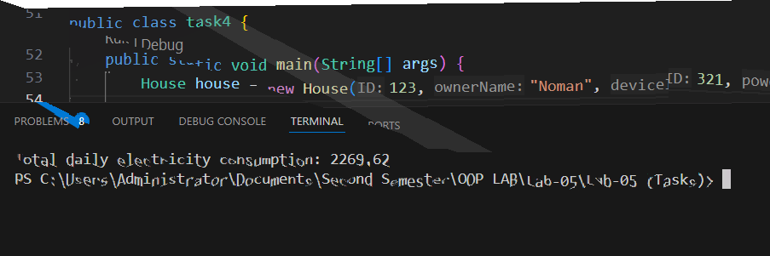
TASK-5 (Code)
class Student {
private int ID;
private String name;
private double marks;

//Getters
public int getID() {
return ID;
}
public String getName() {
return name;
}
public double getMarks() {
return marks;
}

//Constructor
public Student(int ID, String name, double marks) {
this.ID = ID;
this.name = name;
this.marks = marks;
}

//Methods
public void displayStudentDetails() {
System.out.println("==== Student Information ====");
System.out.println("ID: " + ID);
System.out.println("Name: " + name);
System.out.println("Marks: " + marks);
}

public boolean isPassed() {
if(marks >= 40){
return true;
}
else{
return false;
}
}
}

class College {
private String collegeName;
private String city;
private Student[] students; //Student class array object
private int studentCount;

//Constructor
public College(String collegeName, String city, Student[] students) {
this.collegeName = collegeName;
this.city = city;
this.students = students;
this.studentCount = students.length;
}

//Method
public void displayCollegeDetails() {
System.out.println("==== College Information ====");
System.out.println("Name: " + collegeName);
System.out.println("City: " + city);

System.out.println("\n==== Student Information ====");

if(students == null || studentCount == 0) {
System.out.println("No students enrolled!");
return;
}
for(int i=0; i<studentCount; i++){
students[i].displayStudentDetails();
}

int p=0, f=0;
double sum = 0;
for(int i=0; i<studentCount; i++){
sum += students[i].getMarks();
if(students[i].isPassed()){
p++;
}
else{
f++;
}
}
System.out.println("\nTotal Students: " + studentCount);
System.out.println("Passed Students: " + p);
System.out.println("Failed Students: " + f);
System.out.println("Average marks (all students): " + (sum/studentCount));
}
}

public class task5 {
public static void main(String[] args){
Student s1 = new Student(123, "Ali", 70.2);
Student s2 = new Student(456, "Ahsan", 80);
Student s3 = new Student(789, "Owais", 39.33);
Student s4 = new Student(101, "Umer", 66);
Student s5 = new Student(321, "Daniyal", 34.0);

Student[] studentArray = {s1, s2, s3, s4, s5};

College college = new College("FAST-NUCES", "Karachi", studentArray);
college.displayCollegeDetails();
}
}

Output (Task-5(b)):

